ASHUTOSH DASH   
SUPERSET ID – 6363122  
E – COMMERCE

using System;

public class Product : IComparable<Product>

{

public int ProductId { get; set; }

public string ProductName { get; set; }

public string Category { get; set; }

public Product(int id, string name, string category)

{

ProductId = id;

ProductName = name;

Category = category;

}

public int CompareTo(Product other)

{

return this.ProductId.CompareTo(other.ProductId);

}

public override string ToString()

{

return $"ID: {ProductId}, Name: {ProductName}, Category: {Category}";

}

}

public class Program

{

public static Product LinearSearch(Product[] products, int id)

{

foreach (var product in products)

{

if (product.ProductId == id)

return product;

}

return null;

}

public static Product BinarySearch(Product[] products, int id)

{

int left = 0, right = products.Length - 1;

while (left <= right)

{

int mid = (left + right) / 2;

if (products[mid].ProductId == id)

return products[mid];

else if (products[mid].ProductId < id)

left = mid + 1;

else

right = mid - 1;

}

return null;

}

public static void Main()

{

Product[] products = new Product[]

{

new Product(101, "Laptop", "Electronics"),

new Product(102, "T-Shirt", "Clothing"),

new Product(103, "Smartphone", "Electronics"),

new Product(104, "Shoes", "Footwear"),

new Product(105, "Book", "Education"),

};

Console.Write("Enter Product ID to search: ");

int id = int.Parse(Console.ReadLine());

var linearResult = LinearSearch(products, id);

Console.WriteLine("\nLinear Search Result:");

Console.WriteLine(linearResult != null ? linearResult.ToString() : "Product not found");

Array.Sort(products);

var binaryResult = BinarySearch(products, id);

Console.WriteLine("\nBinary Search Result:");

Console.WriteLine(binaryResult != null ? binaryResult.ToString() : "Product not found");

}

}

PRODUCT FOUND OUTPUT :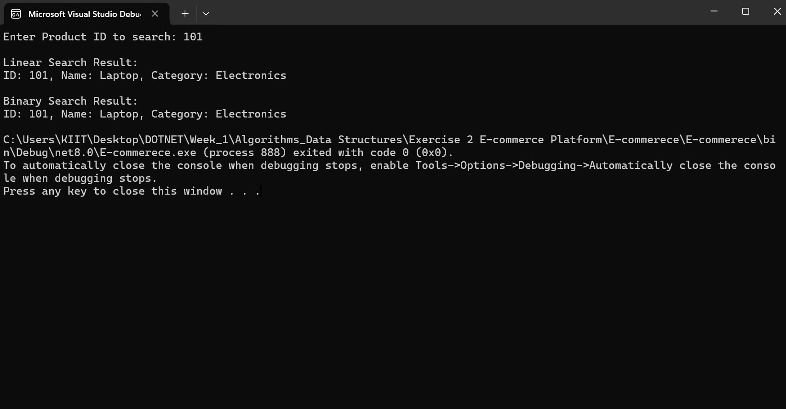

PRODUCT NOT FOUND OUTPUT :

